Project Design Phase-II
Data Flow Diagram & User Stories

Date | 15 February 2026
Team ID | LTVIP2026TMIDS80893
Project Name | Rainfall Prediction System for Agriculture
Maximum Marks | 4 Marks

Data Flow Diagrams:
The Data Flow Diagram represents how user input travels through the system. The farmer enters weather-related parameters in the web interface. The Flask backend processes the input, applies preprocessing (scaling, encoding, imputation), and sends it to the trained Random Forest model. The model generates a rainfall prediction probability, and the system displays either Rain Expected or No Rain Expected along with agricultural advisory.

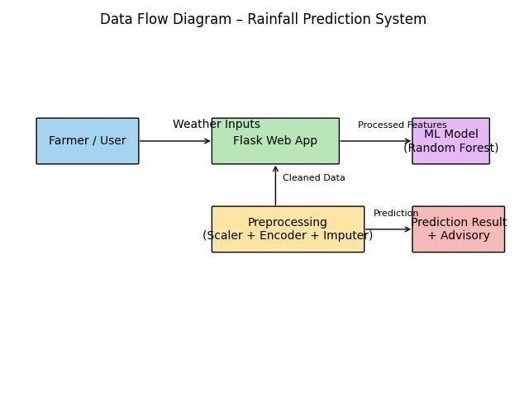

User Stories
Use the below template to list all the user stories for the product.
User Type | Functional  Requirement  (Epic) | User  Story  Number | User Story / Task | Acceptance  criteria | Priority | Release
Farmer  (Web user) | Rainfall  Prediction &  Advisory  System | USN-1 | As a farmer, I can enter weather parameters (temperature, humidity, pressure, rainfall, wind speed, etc.) into the web application. | The system accepts input and processes it without errors. | High | Sprint-1
 |  | USN-2 | As a farmer, I can receive rainfall prediction results with probability percentage. | The system displays  Rain  Expected or  No Rain Expected along with probability. | High | Sprint-1
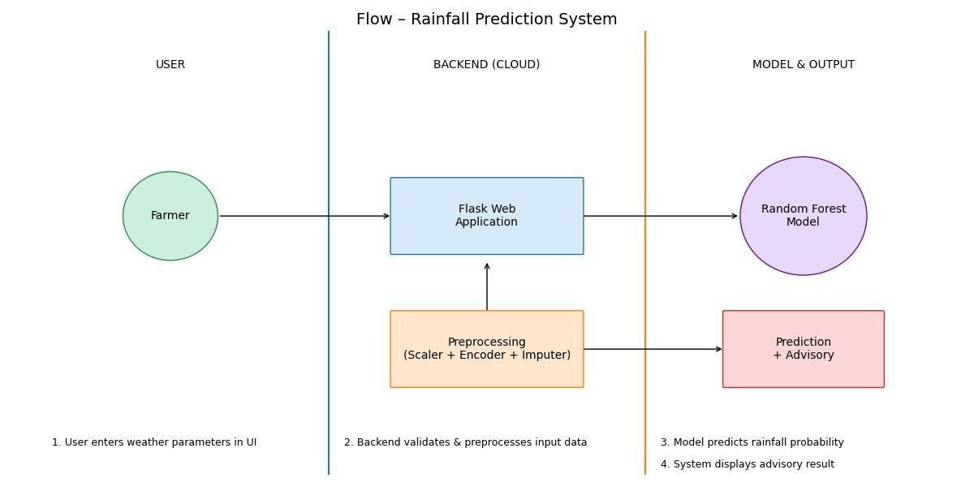

User Type | Functional  Requirement  (Epic) | User  Story  Number | User Story / Task | Acceptance  criteria | Priority | Release
 |  |  | recommendations based on prediction.  through Facebook | dynamically based on result.
Administrator  (User Type) |  | USN-4 | As an  administrator, I can  update or retrain the ML model when new rainfall data becomes available. | Updated model can be deployed without affecting user interface. | Medium | Sprint-2
 |  | USN-5 | As an  administrator, I can monitor system performance and model accuracy. | Model accuracy metrics are available from evaluation reports. | Medium | Sprint-2
 |  | USN-3 | As a farmer, I can view agricultural advisory | Advisory suggestions are shown | High | Sprint -  1

